**How to issue your own token on Ethereum in less than 20 minutes.**

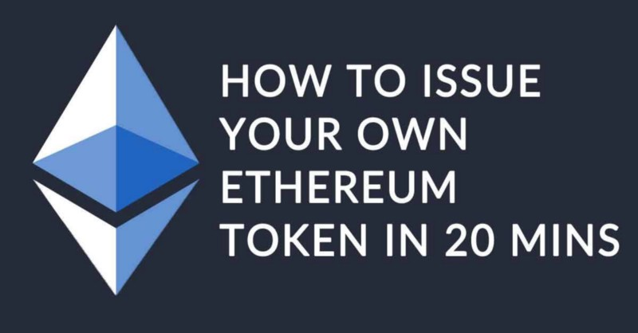

Alright bro, are you telling me that I can issue my own Token, make an ICO, get gazilions of dollars and live the crypto-dream in less than 20 minutes?

The answer is yes, but hopefully you will do better than that.

With the latest news about the Blockchain, Bitcoin, Ethereum, cryptocurrencies, and ICO popping up left, right and center, this Blockchain business is garnering quite a lot of attention. So I’ve put together a tutorial so that you can understand the technology much better and you can become a part of the booming crypto-economy!

This is the first of a series of tutorials to help people better understand how to leverage Blockchain technologies and crypto-currencies to build meaningful applications and nurture the network.

In this tutorial my objective is to walk you through the steps of setting up your account through to issuing your first token on the Ethereum network using a single smart contract and [MyEtherWallet](https://www.myetherwallet.com/" \t "_blank).

The token will be a standard ERC20, it will have the main functions and can be used as a general base for more sophisticated applications than just transferring them (many “half-serious” ICOs have extremely similar contracts)

**WARNING: With great powers come great responsibilities. I’m not responsible for you not being cautious with your ETH, or using these powers for the evil side of force. I truly hope you do good and feel empowered by the potential that this technology puts in the hands of people.**

**Before we start:**

There are a few different components you will need in order to build your own token.

1. Ethereum Address (Ropsten Network)
2. Some Ethereum (Ropsten Network)
3. A text editor (I.e. Sublime / Atom)
4. Solidity contract

**Ethereum address**

* For this tutorial we will use a test network to issue the token so you don’t end up spending real Ether’s. We will use the Ropsten Test network. In order to get started, go to **[MyEtherWallet](https://www.myetherwallet.com/" \t "_blank)**(MEW) and create an account there.
* To get setup, click the right hand side corner, change the network to Ropsten ([MyEtherWallet](https://www.myetherwallet.com/" \t "_blank)) → click the New Wallet →Enter a password you can remember → Download / Save your Keystore file in a safe space → Save your Private Key in a safe space.
* To view your wallet address, go to →View Wallet Info →Private Key → Enter the saved private key →Unlock your Wallet and it should be there!

**Text Editor**

Download one of the following text editors:

* [Sublime Text](https://www.sublimetext.com/)
* [Atom](https://atom.io/)

**Contract**

* Download the smart contract that the legendary Ethereum unicorn rider, [BokkyPooBah](https://medium.com/u/f5b908f9db99" \t "_blank) has helped us to make, by clicking [here](https://github.com/bitfwdcommunity/Issue-your-own-ERC20-token/blob/master/contracts/erc20_tutorial.sol). ⬅️
* You will be editing this code for your own token

**Ropsten Ethers**

We have created our own faucet where you can request Ropsten Ethereum! Just access <https://faucet.bitfwd.xyz/> and put your ropsten address and our smart contract will send you some!

Transfer only once please! And if it doesn’t work let me know in the comments!

**IMPORTANT [Before I forget to ask you!]**

[Make sure you follow me on Twitter for more Crypto EPIC content, I’m building some siiick Blockchain Products, and**I would love to give you exclusive access to them ;) @mrtzneto**](https://twitter.com/mrtzneto)

**Now let’s get started:**

* Open the contract you downloaded in your Text Editor.
* Go to *Line 3–15* and look at the comment section. Although this is a comment section, this will help you down the track. For me, 0Fucks was my first one :). Basically you send 0Fucks to someone when you don’t care.
* Change *Line 4*to the title of your Smart Contract
* Change *Line 6* to the Ropsten Ethereum address you created in MyEtherWallet
* Change *Line 7’s* Symbol to your respective coin name (Keep it short)
* Change *Line 8* to the name of your token

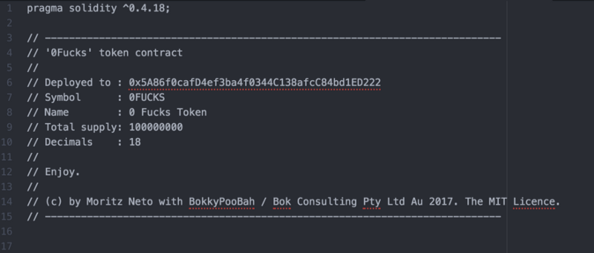

Line 3 — 15

Next:

* Go to *Line 102* and change “FucksToken” to “(YourTokenName)
* Do the same for *Line 115*
* Go to *Line 116*and change the symbol name, the same as the ones you did in the comment section
* Do the same for *Line 117*
* Change *Line 120’s* Address to be the same as the one you generated in MEW
* Same goes for *Line 121*

For the decimals and total supply on *Line 118 and 119,*you can just leave it as it is however I’ll explain it just for visibility. On total supply there are actually a few considerations. First one is that the standard (and max) is 18 decimals, meaning that a coin can be splitted in 18 parts.

The second one is that let’s say for example you want to issue 100 tokens, on the total supply part you have to put 100 followed by the number of decimals that you choose.

Ex: If I want to emit 100 tokens, what I will put on total supply is: 100000000000000000000; and so it goes.

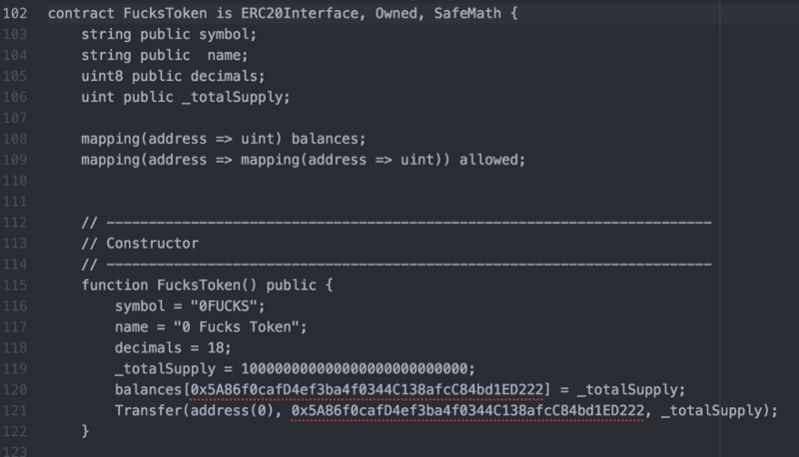

Lines 102–105

After that we are done with editing code. Yep, that was easyyyy. Now we are going to do some cool stuff…

* Go to <http://remix.ethereum.org/>
* In the browser/ballot.sol, paste the code you just edited! If something red comes up, there is something wrong in the code. If there is yellow warning it’s alright, let’s hope for the best.
* Now Under Compile →Details →Choose the Token you are creating
* Under ByteCode press the 📋button to copy the ByteCode to your clipboard —( Into this section, what may appear are different things on the ByteCode. What you have to copy is the “object” ByteCode, adding a 0x in the beginning. So you will have 0xByteCode.)

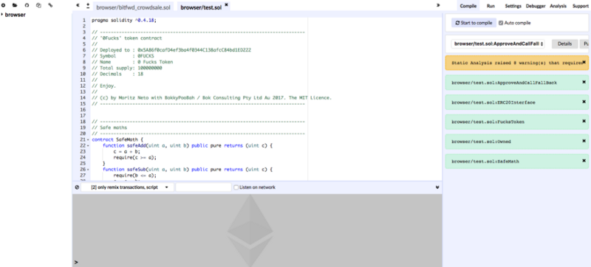

Remix Editor

* Go to MEW where we will start to deploy the contract. Remember we want to be on the Ropsten Test Network so make sure the top right hand corner says
* Navigate to the Contracts tab → Press Deploy Contract
* Paste your ByteCode into the ByteCode box. Your gas limit should automatically update
* Access your wallet by going into the Private Key → Enter your private key →Unlock your wallet
* Now press Sign Transaction →Deploy Transaction

***ATTENTION: This is the moment where you have to cross your fingers for the first time during a few seconds. 🤞***

Click on the transaction tx or access [https://ropsten.etherscan.io](https://ropsten.etherscan.io/) to check if the contract went through. If it didn’t, start again and try to figure it out what you got wrong. If it did, you are a basically Vitalik 2.0, be proud.😎

If everything works out, this is a sample image of what you should be seeing.

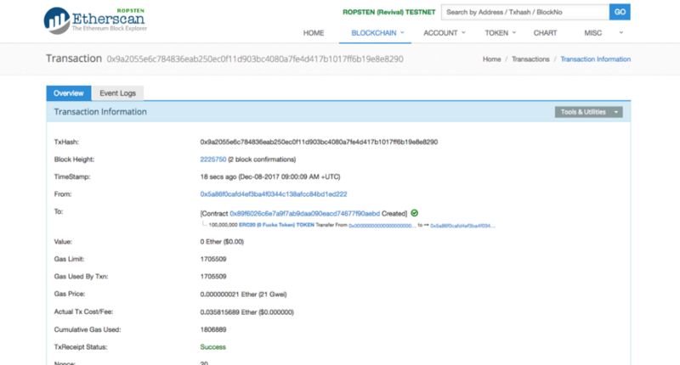

Now we are going to register this contract. To do that:

* In the Overview Tab → Click on the Contract Address
* Go to the Contract Code Tab → Click Verify and Publish

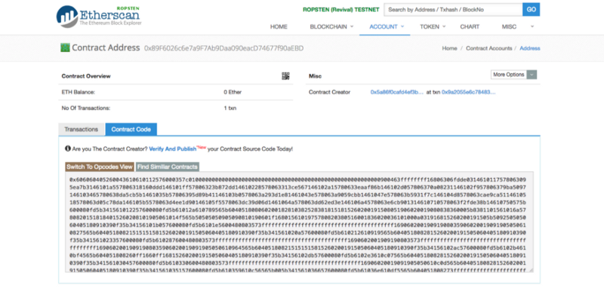

Nearly there… The following steps are ***really***important. So look carefully. Basically what we are doing here is trying to guarantee that the code fits what you saying you are deploying and registering this on the network. **FOREVER**.

So if you commit mistakes, it will be wrong forever. What a friend told me that on the Blockchain:

*Get it right once or get it wrong forever.*

Now you have 5 things to do on this page.

1. Be sure that the contract address field corresponds to the contract address that you have just deployed. Remember contract address is different to the MEW address you created so make sure not to get them confused
2. The contract name has to match the one in the code, in my case is this: **contract FucksToken.**This was on Line 102 in your code
3. To check which version of the complier, go back to the remix page where you got the BYTECODE from and look at the URL, the complier version will be there. In most cases it should be: *v0.4.19+commit.c4cbbb05.js , but you want to try updated ones if by any chance this doesn’t work.*
4. On **Optimisation**, choose No (We haven’t enable it before).
5. On ENTER THE SOLIDITY CONTRACT CODE BELOW, copy the whole code from Remix, and paste in that area. NOT THE BYTECODE, but the code itself. Can also be copied from your text editor.

Now, leave the other fields in blank and click on Verify and Publish.

But be aware… This is the moment that you were waiting for… It is about to happen!

**FINGERS CROSSED AGAIN FOR VITALIK’S SAKE. 🤞**

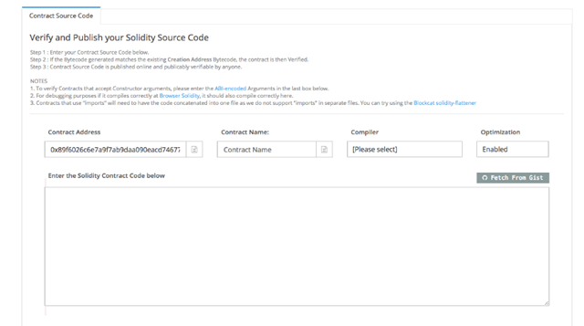

The final boss…

The moment of truth…

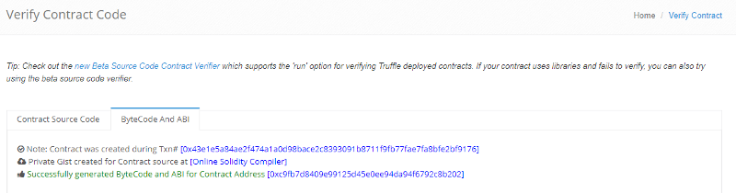

Success!!!

If a success page come along with green checkmarks and stuff, you did it! You’ve made it, I’m proud of you, now you are a cypher punk, a part of the crypto movement. Yaaaaaaay!

If a red message comes along…try it again and see where you might have missed a step. I’m happy to help if you leave a comment below but remember Google is your best friend 😉

To confirm that it works, go to <https://ropsten.etherscan.io/> and look into your MEW Address, not the contract one, but your public address. If you can see your coins there, now you can relax and live the crypto dream in peace! At least until the next BTC rally :)))))

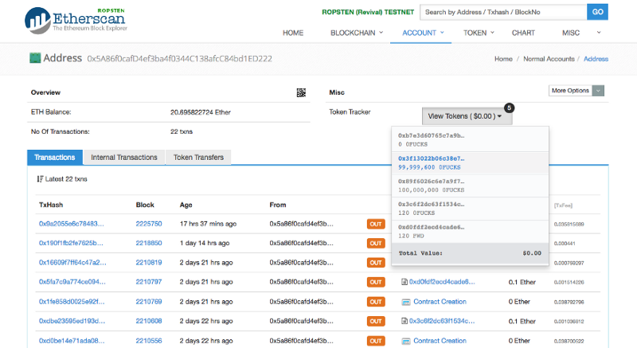

To be able to send these tokens, you need to access your MEW account by Viewing Wallet Info →Accessing and putting in your private Key →Unlocking Wallet →Select the option Load Tokens. After that they will show up to be transferable.

**Final Considerations:**

You just made your own Cryptocurrency Token. This is the simplest way I have been able to put a token together. However, this is just the token creation process, it is not a crowd sale contract. I will upload another tutorial very shortly.

You’ve just unlocked some Blockchain superpowers and I hope this helped you become more interested and involved with the amazing space. But remember that with great powers come great responsibilities. I truly hope you use your ideas for good and don’t be another scam.

Leave any questions or comments in the section below and share with everyone if you are working on something interesting. The bitfwd community is always keen to help with cool and meaningful projects.